**Department of Computer Science**

**LAB TASK # 2(State Machine Diagram)**

**Question 1/Task 1**

**Answer:**

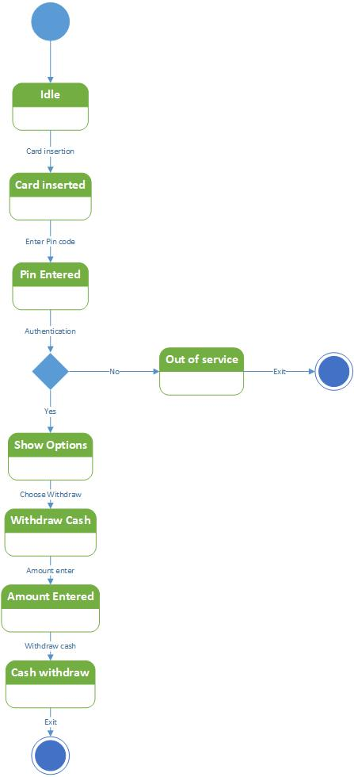

**Question 2/Task 2: Modeling a Word Processor**

**Answer:**

